Hermite distribution

Def

Parameter



Support



PDF

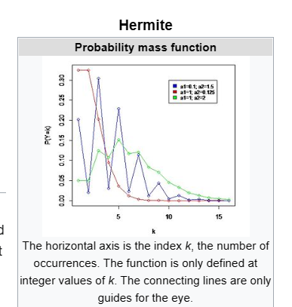

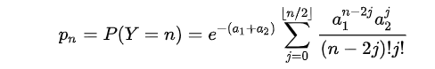

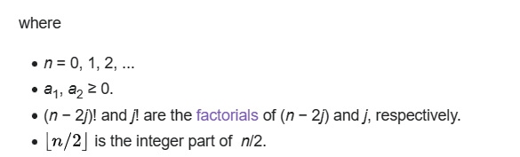

CDF

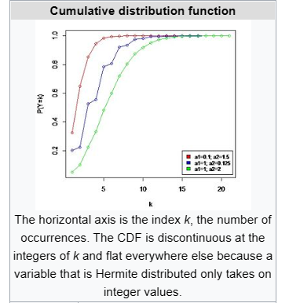

Expected Value



Variance



Skewness



Ex. Kurtosis



Relationship about kurtosis, excess kurtosis,

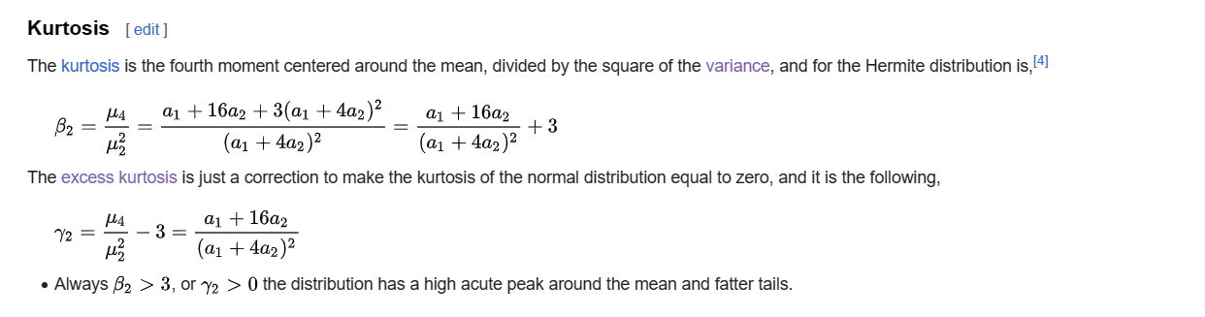

MGF



CF



PGF



Moment



CGF



Ref

[Hermite distribution - Wikipedia](https://en.wikipedia.org/wiki/Hermite_distribution)